Input Variable Test Cases

Expected Valid Testing
Variable Name | Stage in quiz | Input | Expected output | Test result | Actual Output | Test result explanation | TEST TYPE | Action taken to fix
IATACode | Please enter the IATA Code | ABC | Valid
IATACode | Please enter the IATA Code | XYZ | Valid
IATACode | Please enter the IATA Code | ABCD | Invalid. Please try again.
IATACode | Please enter the IATA Code | XY | Invalid. Please try again.
“Name” | Please enter the name | A | Valid
“Name” | Please enter the name | ABCDEFGHIJKLMNOPQRSTUVWXYABCDEFGHIJKLMNOPQRSTUVWX | Valid

Boundary Testing:
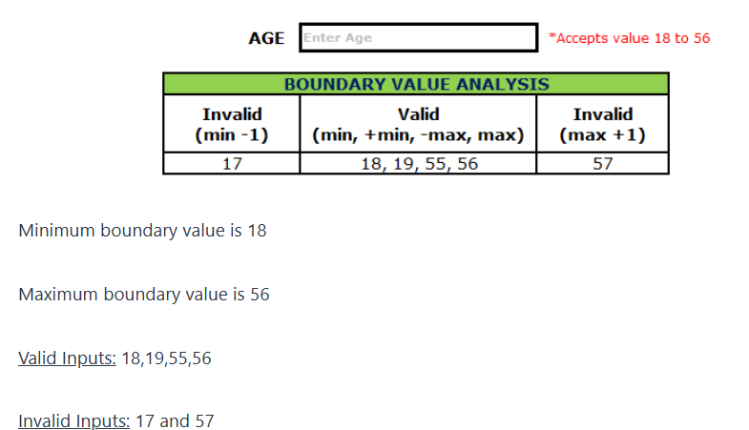

Variable Name | Stage in quiz | Input | Expected output | Test result | Actual Output | Test result explanation | TEST TYPE | Action taken to fix
Age | Please enter Age | 18 | Welcome to the Game | Pass | Welcome to the Game | Test allowed values between 18-56 | Minimum Boundary (Valid) | N/A
Age | Please enter Age | 56 | Welcome to the Game | Pass | Welcome to the Game | Test allowed values between 18-56 | Max Boundary (Valid) | N/A
Age | Please enter Age: | 17 | Invalid input, please use value between 18 -56 | Fail | Welcome to the Game | Test allowed invalid Age | Minimum Boundary -1 (Invalid) | Changed ….. to … to catch Age
Age | Please enter Age: | 17 | Invalid input, please use value between 18 -56 | Pass | Invalid input, please use value between 18 -56 | Test did allowed invalid Age | Minimum Boundary -1 (Invalid) | N/A
Age |  |  |  |  |  |  | Maximum Boundary -1 (valid)
Age | Please enter Age: | 57 | Invalid input, please use value between 18 -56 | Pass | Invalid input, please use value between 18 -56 | Test did allowed invalid Age | Maximum Boundary +1 (Invalid) | N/A

Invalid Testing
Variable Name | Stage in quiz | Input | Expected output | Test result | Actual Output | Test result explanation | TEST TYPE | Action taken to fix
Age | Please enter Age | $% | Invalid input, please use value between 18 -56 and not other characters. Please try again | Fail | Welcome to the Game | Test allowed invalid Age or characters | Invalid | Changed ….. to … to catch Invalid Input
Age | Please enter Age | $% | Invalid input, please use value between 18 -56 and not other characters. Please try again | Pass | Invalid input, please use value between 18 -56 and not other characters. Please try again | Test allowed values between 18-56 | Invalid | N/A

